November 12th, 2006
Hi
The layout for this letter was copied from the letter for November 13th last year. But, in looking at that letter, I see that a lot of the content is similar to what I have to say this time; I guess this is because life goes round in a cycle repeating itself. So, instead of deleting all the content, I will delete some and modify the rest. New content is in blue.
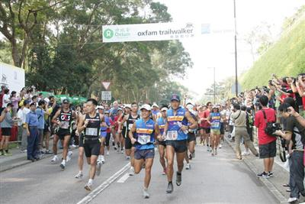
I started my ‘winter’ runs yesterday with the same short run as last year in the Tai Po/Lead Mine Pass/Tai Po Kau forest area (with most of the part from Lead Mine Pass to Tai Po being the route in the reverse direction, Leonie, we did last year, except that I stuck to the road and didn’t use the forest track). However, the ‘run’ was terrible! At 2 hr, 12 min, it was 20% slower than my best of 1 hr 50 min. I could hardly run at all; I even had to stop and walk going downhill! I have had a pretty tough past year with the operations and the pressure and stress from writing/revising the two books. I would not be surprised if that was part of the reason for the difficulty. Yesterday, the temperature for the ‘run’ was 28⁰C with high humidity. This temperature was hotter than for any of my runs last season (except for the last run which was the same temperature).
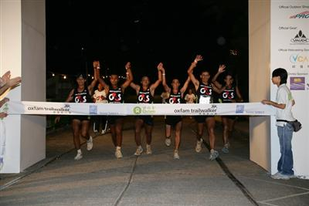
This weekend is also the time for the annual Oxfam Trailwalker over the 100 km Maclehose trail. In my hike yesterday, I passed some of them on the way up to Grassy Hill. Although it is not officially a race, many teams regard it as that. Once again, the Ghurkha team (who are employed by the Securicor security company) won with a time of 12 hr 11 min, which was 14 minutes outside the record they set in 2004. This is the fourth year in a row they have won. All this puts to shame my solo Maclehose Trail run, many years ago which took me about 22 hours. But, of course, doing it solo is more difficult. I had to carry a backpack full of food and especially water (which eventually ran out) and no team members for encouragement meant that motivation was sometimes difficult. With teams, water and food are provided at regular intervals, together with changes of clothes and footwear if necessary. In the Trailwalker, the organisers also provide first aid and massage for walkers. This year, Oxfam had a webcam set up at the finish line so I watched the winners end their race. Knowing that they started at 9 am, I knew they would finish about 9 pm so began to watch at about 8:30 pm. In addition, it was possible to track the times of every team as they passed through the checkpoints. As teams are allowed 48 hours to finish, the webcam is probably still on; if you want to have a look, you might see some teams staggering across the finish line. Go to:
http://www.vcast.tv/trailwalker2006/index_eng.asp
Or, go to the Oxfam website and click on ‘OTW Webcasting’:
http://www.oxfamtrailwalker.org.hk/en/about/site_map.html
The hotel swimming pool closes on Wednesday until March. It used to be open the whole year, except for 2 weeks of maintenance, but during the winter, only one or two people used it, including me. This past week I had three swims and covered a total of 5.5 km.
Talking about exercise, last week’s TIME [2005] had its major article about diet and exercise. Among the letters of response in this week’s issue, one was from a woman saying that each week she swims 2 x 1000 yards, briskly walks 3 x 2 miles, lifts weights and occasionally plays tennis. A remarkable physical regime, and especially considering that she is 89 years old!!
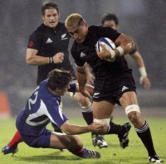
The All Blacks played France last night in a game starting at 9 pm! They had another good win at 47 – 3, running in 7 tries to nil. There is a second test in Paris next weekend. There was a lot of international rugby. In some other games, Ireland beat SA, the Pumas (Argentina) beat England Australia just beat Italy in Rome.

The annual Formula 3 Grand Prix in Macau is next weekend.
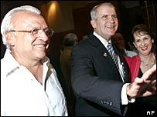
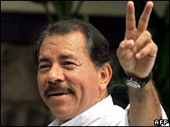
Well, it has not been a good week for President Bush, has it, with his party losing out heavily in the mid-term congressional elections. Also, the socialist candidate Daniel Ortega became president in Nicaragua. This is the same ‘leftist’ leader who fought against the US- funded ‘Contras’ about 20 years ago that lead to the ‘Iran-Contras’ scandal. And, Gavin, you will like this – Bush sent a representative to Nicaragua to oppose Ortega’s campaign and warn against voting for him. This representative was none other than Oliver North of Iran-Contra scandal infamy.
Left: Daniel Ortega
Right: Oliver North with the conservative candidate

HK's former Director of Health Margaret Chan was elected as the next director of the World Health Organisation. She was nominated by China, who did all they could to ensure she was elected! Chan was in charge in HK during the ‘Bird flu’ time and the SARS crisis. For the former, all chickens in HK were culled which stopped the spread of the disease. During SARS, she was severely criticised for some of her actions; however, this may be of benefit to her in her new role.
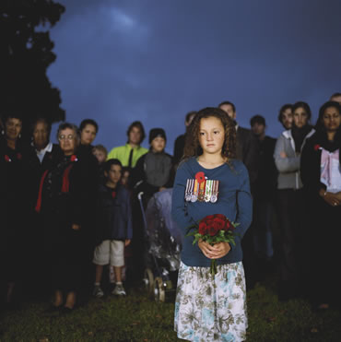
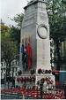
Old Star Ferry pier on HK side closed after final crossing last night. Today is Remembrance Sunday in commonwealth countries. The pictures show the Cenotaph in London and at a dawn service in NZ (not sure if it is in Gisborne or Auckland).
That’s about it for now.


Cheers

